Reading a Sun-Path Diagram (aka an Altitude-Azimuth Graph). Name: ________________________________
The altitude angle is the angle of the sun above the horizon.
The azimuth angle is the angle of the sun around from north at any given time.
Sun-path diagrams (aka altitude-azimuth graphs) show a 3D phenomenon (the movement of the sun in a 3D space) in 2D. The azimuth angle is more intuitive on the graph because if you’re facing north holding the graph flat, it’s easy to see the sun’s azimuth at any given time. The altitude angle is less intuitive on the graph because it’s trying to represent an angle above the horizon on a flat surface.
This graph shows that in Sydney at 11 am on August 1 every year, the Sun is at an altitude of about 36°, which means it is 36° above the horizon. (You read off the red circles.) It’s azimuth at this time and date is about 18° (which means it as angle of 18° around from north).
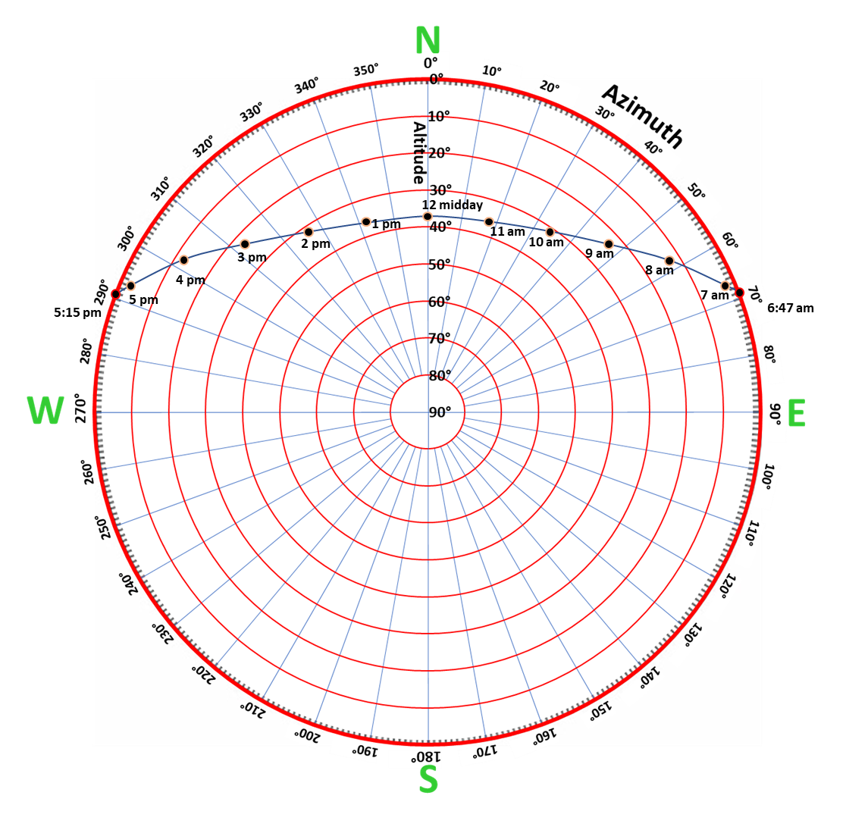
Altitude-Azimuth Graph for
Sydney, Australia
August 1
Sunrise
Sunset
Questions:
- The altitude of the sun at 8 am on August 1 in Sydney is about ________ and its azimuth is about ________.
- The altitude of the sun at 2 pm on August 1 in Sydney is about ________ and its azimuth is about ________.
- On August 1 in Sydney, the sun reaches an elevation of 20° at approximately _________am, which is about ___________ hours after sunrise. Its azimuth at this time is ___________. As the Sun descends, it again hits an elevation of 20° at about ________ pm, which is about __________ before sunset. Its azimuth is _________.
- The highest elevation of the sun on this day is about ________ and it occurs at about ____________. (On this day, solar noon coincides to the nearest minute with 12:00 pm, or “midday”, but this is quite unusual.)
- What do you notice about the altitude and azimuth of the sun 3 hours before solar noon and 3 hours after solar noon? ________________________________________________________________________________

